

ALCOHOL DETECTION AND ENGINE
CUT-OFF SYSTEM

A PROJECT REPORT

Submitted by

GURU KARTHICK N S | - 710723149019
HAREESH N | - 710723149020
HARIHARA SUDHAN K K | - 710723149021

in partial fulfillment for the award of the degree
of
BACHELOR OF ENGINEERING
in

COMPUTER SCIENCE AND ENGINEERING

(CYBER SECURITY)

Dr. N.G.P. INSTITUTE OF TECHNOLOGY, COIMBATORE - 641048
AN AUTONOMOUS INSTITUTION

ANNA UNIVERSITY: CHENNAI-600025

MAY 2025

ANNA UNIVERSITY : CHENNAI 600 025

BONAFIDE CERTIFICATE

Certified that this Report “ALCOHOL DETECTION AND ENGINE CUT-OFF SYSTEM” is the bonafide work of “GURU KARTHICK N S (710723149019), HAREESH N (710723149020), HARIHARA SUDHAN K K (710723149021)” who carried out the project work under my supervision.

SIGNATURE  M. KALAISELVI M.E.,  SUPERVISOR | SIGNATURE  Dr. D.PALANIKKUMAR M.E, Ph.D.  HEAD OF THE DEPARTMENT
Assistant Professor (Sr.Gr.),  Department of Computer Science and  Engineering (Cyber Security), | Professor & Head,  Department of Computer Science and  Engineering,
Dr. N. G. P Institute of Technology,  Coimbatore-641048. | Dr. N. G. P Institute of Technology,  Coimbatore-641048.

Submitted for the End Semester 22UCC407 - Idea & Design Sprint Viva-Voce Examination held on ______________

_ _ _ _ _ _ _ _ _ _ _ _ _ _ _ _ _ _ _ _ _ _ _ _ _ _ _ _ _ _ _ _ _ _ _ _ _ _

INTERNAL EXAMINER EXTERNAL EXAMINER

DECLARATION

I hereby declare that the project work entitled “ALCOHOL DETECTION AND ENGINE CUT-OFF SYSTEM” submitted to the autonomous 22UCC407-Idea & Design sprint viva voce – May 2025 is the report of the original project work done by us under the guidance of M. KALAISELVI M.E., Assistant Professor (Sr.Gr.), Department of Computer Science and Engineering (Cyber Security), Dr.N.G.P Institute of Technology, Coimbatore- 641 048.

NAME | SIGNATURE
GURU KARTHICK N S  HAREESH N  HARIHARA SUDHAN K K | _________________________  _________________________  _________________________

I certify that the declaration made by the above candidate is true.

Project Guide

M. KALAISELVI M.E.,
Assistant Professor (Sr.Gr.),
Department of Computer Science and Engineering (Cyber Security),
Dr. N. G. P Institute of Technology,
Coimbatore-641048.

ACKNOWLEDGEMENT

Words act as gateway to express tokens of acknowledgement. First of all, we would like to thank the supreme power, our Parents and Almighty God, who has given us the strength and courage to complete our work successfully.
We would like to express our profound gratitude and deep sense of thanks to
Dr. Nalla G. Palaniswami MD., AB (USA), Chairman of Kovai Medical Center & Hospital, for providing us with the necessary facilities to complete our project work effectively.
Our heartfelt gratitude to Dr. Thavamani D Palaniswami MD., AB (USA), Secretary of Dr. N. G. P. Institute of Technology, for her generous attitude and constant motivation, which had been one of the sole reasons to complete our project.
We are sincerely grateful to Dr. S. U. Prabha M.E, Ph.D. Principal who has always been a source of inspiration, well-wisher and a pillar of support for all the students in our institution by rendering full motivation always.
We are highly indebted to Dr. D. Palanikkumar M.E, Ph.D. Professor and Head of the Department, Department of Computer Science and Engineering, for his dedication, keen interest and overwhelming attitude to help his students that have helped us to a very great extent to accomplish this task.
We wish to thank our Idea & Design Sprint Coordinator Ms. S. Gomathi, M.E, (Ph.D), Assistant Professor, Department of Computer Science and Engineering, for her excellent assistance, aspiring guidance, regular feedback and invaluably constructive ideas.
We express our hearty thanks to our Project Guide M. Kalaiselvi M.E., Assistant professor (Sr.Gr.), Department of Computer Science and Engineering (Cyber Security), for his valuable guidance and timely help for completing our project.
Finally, we owe huge thanks to our teaching Faculty members and Non- teaching staff members, whose love and insights have so deeply enriched our work.

ABSTRACT

This project is designed to prevent drunk driving by integrating alcohol detection with vehicle engine control. Using an alcohol sensor, such as the MQ-3, the system monitors the driver's blood alcohol concentration (BAC) through breath analysis. If the BAC exceeds a preset limit, the system automatically disables the engine, preventing the vehicle from starting or continuing to run. Additionally, the system features a GSM module that sends an SMS alert to the vehicle owner whenever the alcohol detection system is activated, providing real-time updates on the driver’s alcohol level and the vehicle’s status. This not only ensures safer driving but also allows vehicle owners to monitor and secure their vehicles remotely. The system can be easily integrated into existing vehicle models with minimal modifications, making it a cost-effective solution for enhancing road safety. By automating the alcohol detection process and removing human intervention, it eliminates the risk of impaired driving. Furthermore, it promotes responsible behavior by discouraging individuals from attempting to drive under the influence, knowing that the vehicle will not operate until they are sober. This combination of prevention, real-time alerts, and ease of use makes the system an invaluable tool for reducing alcohol-related accidents and improving overall road safety. This project aims to reduce alcohol-related accidents and vehicle misuse by offering an affordable, real-time solution that enhances both road safety and vehicle security.

LIST OF FIGURES

FIGURE NO | TITLE | PAGE NO
3.1 | Block diagram | 7
3.2 | Proposed module | 8
4.1 | ARDUINO UNO | 10
4.2 | MQ-3 Sensor | 13
4.3 | GSM 900a MODULE | 13
4.4 | 5V Relay module | 17
4.5 | LCD Display | 18
4.6 | Arduino IDE | 20
6.1 | Alcohol detection and Engine cutoff system | 26
6.2 | Safe state of the system | 27
6.3 | Unsafe state of the system | 27
6.4 | Intimation through message | 28

TABLE OF CONTENTS

CHAPTER NO | TITLE | PAGE NO.
 | ABSTRACT | v
 | LIST OF FIGURES | vi
 | LIST OF TABLES | vii
1 | INTRODUCTION | 1
 | 1.1 Need of the project | 1
 | 1.2 Objective | 2
 | 1.3 Organization of the report | 2
 | 1.4 Summary | 3
2 | LITERATURE SURVEY | 4
3 | PROBLEM STATEMENT AND PROPOSED SYSTEM | 5
 | 3.1 Introduction | 5
 | 3.2 Existing system | 5
 | 3.3 Drawbacks of existing system | 6
 | 3.4 Problem statement | 6
 | 3.5 Proposed system | 6
 | 3.6 Advantages of proposed system | 7
 | 3.7 Modules of proposed system | 8
 | 3.8 Summary | 9
4 | COMPONENTS | 10
 | 4.1 Hardware components | 10
 | 4.1.1 ARDUINO UNO | 10
 | 4.1.2 MQ-3 SENSOR | 11
 | 4.1.3 GSM 900a MODULE | 13
 | 4.1.4 RELAY MODULE | 16
 | 4.1.5 LCD DISPLAY | 18
 | 4.2 Software required | 18
 | 4.2.1 ARDUINO IDLE | 18
5 | PROPOSED METHODOLOGY | 24
 | 5.1 Introduction | 24
 | 5.2 Module description | 24
 | 5.3 Summary | 25
6 | IMPLEMENTATION AND RESULTS | 26
 | 6.1 Results | 27
 | 6.2 Summary | 28
7 | CONCLUSION AND FUTURE WORK | 29
 | 7.1 Conclusion | 29
 | 7.2 Future work | 29
 | REFERENCES | 30

CHAPTER-1
INTRODUCTION

Drunk driving continues to be one of the leading causes of road accidents worldwide, contributing to a significant number of fatalities and injuries every year. Despite numerous awareness campaigns and stricter laws, impaired driving remains a persistent threat to public safety. In this context, the Alcohol Detection and Engine Cut-Off System offers an innovative solution by integrating alcohol detection technology with vehicle engine control. This system aims to prevent drunk driving by automatically disabling a vehicle’s engine when alcohol levels in the driver’s breath exceed a safe threshold. By incorporating a breath alcohol sensor (such as the MQ-3), the system continuously monitors the driver's blood alcohol concentration (BAC). If the BAC exceeds the preset limit, the engine is automatically shut down, ensuring the driver is not able to operate the vehicle under the influence. Furthermore, the inclusion of a GSM module enhances the system by sending real-time SMS alerts to the vehicle owner, notifying them of potential misuse or impaired driving. This project seeks to address a critical issue in road safety and offers an effective and practical solution to reduce alcohol-related accidents on the road.
1.1 NEED OF THE PROJECT
The need for this project arises from the increasing number of alcohol-related accidents and fatalities on the roads. Despite legal regulations and public awareness campaigns, people still continue to drive under the influence of alcohol, often putting their lives and others' lives at risk. Current vehicle security systems do not address the issue of impaired driving effectively. There is a clear gap in existing vehicle safety technologies when it comes to preventing drunk driving in real-time. This project aims to fill that gap by providing an automated system that not only detects alcohol levels but also prevents the vehicle from operating under unsafe conditions, thereby preventing accidents before they occur. Additionally, the GSM-based alert system keeps the vehicle owner informed of any abnormal driving conditions, enhancing vehicle security.
1.2 OBJECTIVE
- To design an alcohol detection system that monitors the driver’s blood alcohol concentration (BAC) in real-time.
- To integrate the alcohol sensor with the vehicle’s ignition system, disabling the engine if BAC exceeds a safe threshold.
- To incorporate a GSM module that sends SMS alerts to the vehicle owner when alcohol is detected or the engine is cut off.
- To ensure the system is cost-effective and easily integrable into existing vehicle models.
- To enhance road safety by preventing drunk driving and promoting responsible vehicle use.
1.3 ORGANIZATION OF THE REPORT
The basic organization of the report is as given below,
Chapter 1: This chapter deals with the introduction and the overview to have a basic idea of the project.
Chapter 2: This chapter deals with the Literature survey for the better understanding of relevance for the enhancement of the proposed work.
Chapter 3: This chapter describes about the proposed work and the technology used to improvise the project.
Chapter 4: This chapter deals with the hardware components and software which are used in this project.
Chapter 5: This chapter gives with the proposed methodology which are used in the project.
Chapter 6: It gives the Project's outcomes and analyses.
Chapter 7: Discusses the conclusion reached and the extent of future project work.
1.4 SUMMARY
This chapter introduces the Alcohol Detection and Engine Cut-Off System, designed to prevent drunk driving by automatically disabling a vehicle's engine if the driver’s blood alcohol concentration (BAC) exceeds a safe threshold. The system uses an alcohol sensor integrated with the vehicle's ignition and a GSM module to alert the vehicle owner via SMS when alcohol is detected. This project aims to enhance road safety, reduce alcohol-related accidents, and provide a cost-effective, easily implementable solution to prevent impaired driving while offering real-time vehicle monitoring.

CHAPTER-2
LITERATURE SURVEY

The issue of drunk driving has led to the development of various alcohol detection systems aimed at reducing alcohol-related accidents. One prominent solution is the Breath Alcohol Ignition Interlock Devices (BAIID), which require drivers to provide a breath sample before starting the vehicle, proving effective in legal contexts to reduce recidivism among offenders. These systems have inspired research into integrating alcohol detection with vehicle control mechanisms, such as using sensors like the MQ-3 to monitor the driver’s blood alcohol concentration (BAC) in real-time and automatically disable the engine if unsafe levels are detected. Studies show that electrochemical sensors can accurately detect alcohol vapor, making them suitable for automotive use. Additionally, GSM-based systems are being explored to enhance security by sending real-time alerts to the vehicle owner via SMS, informing them of any alcohol detection or engine cut-off. While these technologies offer promising solutions, challenges like sensor accuracy, environmental influences, and user acceptance persist, hindering large-scale implementation. Future developments are focused on improving sensor reliability, reducing costs, and integrating these systems into existing vehicles with minimal modifications. Overall, the research underscores the potential of these integrated systems to enhance road safety and prevent impaired driving, although further advancements are needed to overcome current limitations.

CHAPTER-3
PROBLEM STATEMENT AND PROPOSED SYSTEM

3.1 INTRODUCTION
Drunk driving is a leading cause of road accidents, and existing systems fail to effectively prevent impaired driving in real-time. Traditional methods, such as breathalyzer tests and police checkpoints, are reactive and often not available during crucial moments. The proposed Alcohol Detection and Engine Cut-Off System aims to address this issue by automatically detecting alcohol in a driver’s breath and disabling the vehicle’s engine if the alcohol level exceeds a safe threshold. Additionally, a GSM module will alert the vehicle owner via SMS, ensuring immediate notification and greater control. This system offers a proactive solution to enhance road safety and prevent drunk driving accidents.

3.2 EXISTING SYSTEM
Existing alcohol detection systems in vehicles typically use breathalyzer-type sensors to monitor the driver’s alcohol levels and prevent the engine from starting if the BAC exceeds a safe limit. However, these systems lack a feature to notify the vehicle owner or others when the engine is disabled, leaving no immediate way to alert someone of impaired driving or potential misuse.

3.3 DRAWBACKS OF EXISTING SYSTEM
Lack of Real-Time Alerts: Existing systems do not provide immediate notifications to the vehicle owner when alcohol is detected or when the engine is disabled, leaving no way to respond quickly to potential misuse.
Manual Calibration: Some systems require manual calibration and regular maintenance, which can be cumbersome and time-consuming, especially in vehicles without a dedicated service infrastructure.
No Remote Monitoring: Existing systems lack the ability to remotely monitor or track the vehicle’s status, leaving owners unaware of any issues unless they are physically present or involved in the incident.
3.4 PROBLEM STATEMENT
Drunk driving continues to be a major cause of road accidents, leading to significant injuries and fatalities worldwide. Despite laws and enforcement measures, many individuals still drive under the influence of alcohol, posing a serious risk to themselves and others. Current alcohol detection systems in vehicles are limited in their functionality, as they do not offer real-time alerts to vehicle owners or authorities when alcohol is detected, nor do they prevent the engine from running in such situations. There is a need for a more effective, integrated solution that not only detects alcohol levels but also ensures immediate intervention and communication through real-time alerts.
3.5 PROPOSED SYSTEM
The proposed Alcohol Detection and Engine Cut-Off System aims to address the shortcomings of existing systems by integrating alcohol detection with real-time communication features. Using an alcohol sensor (such as the MQ-3), the system continuously monitors the driver’s blood alcohol concentration (BAC). If the BAC exceeds a predefined safe limit, the system automatically disables the vehicle’s engine, preventing impaired driving. Additionally, a GSM module sends an SMS alert to the vehicle owner, informing them about the alcohol detection and engine cut-off. This system offers a proactive solution to enhance road safety and provides greater security to vehicle owners by keeping them informed remotely.

ARDUINO UNO
MQ-3 SENSOR
RELAY MODULE
GSM MODULE

Figure.3.1 – Block diagram
3.6 ADVANTAGES OF PROPOSED SYSTEM
Real-Time Alerts: The GSM module ensures that the vehicle owner is instantly notified via SMS if alcohol is detected, allowing for quick action and response.
Enhanced Safety: The system automatically disables the vehicle’s engine if the driver is under the influence, preventing accidents due to drunk driving.
Remote Monitoring: Vehicle owners can monitor the status of their vehicle from a distance, adding an extra layer of security and control.
Integration with Existing Vehicles: The system can be easily integrated into existing vehicle models with minimal modifications, offering a practical solution for all types of vehicles.
3.7 MODULES OF PROPOSED SYSTEM
Alcohol Detection Sensor (MQ-3): This module detects the presence of alcohol in the driver’s breath and measures the BAC in real-time.
Microcontroller (Arduino UNO): The microcontroller processes the input from the alcohol sensor and controls the vehicle’s engine based on the BAC level.
Engine Cut-Off Mechanism: This module automatically disables the vehicle’s engine if the BAC exceeds the predefined safe limit, preventing the vehicle from operating.
GSM Module (SIM900a): The GSM module sends SMS alerts to the vehicle owner when alcohol is detected or the engine is cut off, keeping them informed remotely.
Power Supply: Provides the necessary power to all components of the system, ensuring uninterrupted operation.
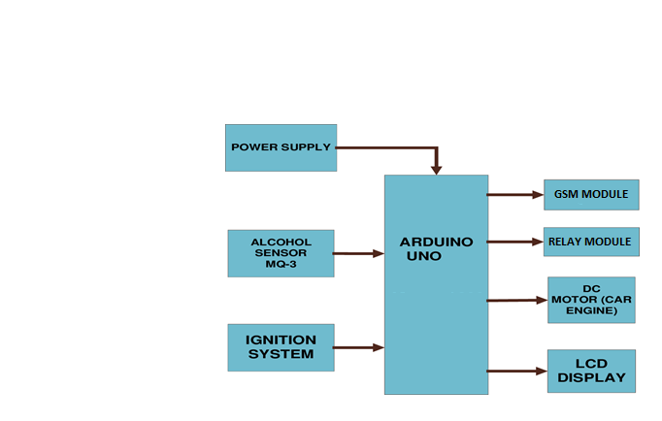
Figure.3.2 – Proposed module
3.8 SUMMARY
This chapter presents the problem of drunk driving and outlines the proposed solution: the Alcohol Detection and Engine Cut-Off System. The system integrates an alcohol sensor, microcontroller, engine control mechanism, and GSM module to offer a proactive approach to preventing impaired driving. The system enhances safety by automatically disabling the vehicle’s engine and alerting the vehicle owner in real time. This solution aims to reduce alcohol-related accidents and offers a cost-effective, easily implementable option for improving vehicle security and road safety.

CHAPTER 4
COMPONENTS

4.1 HARDWARE COMPONENTS
4.1.1 ARDUINO UNO
The Arduino Uno board stands as a cornerstone in the world of electronics prototyping and DIY projects. Featuring an ATmega328P microcontroller, it offers a user-friendly platform for beginners and advanced users alike to bring their ideas to life. With its array of digital and analog input/output pins, the Uno enables interfacing with a wide range of sensors, actuators, and peripherals. Its simplicity in design and programming, facilitated by the Arduino IDE, makes it accessible even to those new to electronics and programming. From controlling LEDs to building complex robotics projects, the Arduino Uno's versatility and affordability have made it a beloved tool among hobbyists, educators, and professionals worldwide, fostering a vibrant community of enthusiasts and innovators.
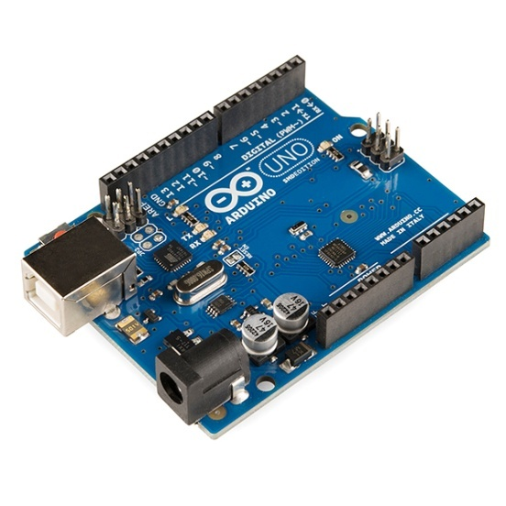

Figure 4.1 ARDUINO UNO
Specification:
- Microcontroller: ATmega328P
- Operating Voltage: 5V
- Input Voltage (recommended): 7-12V
- Digital I/O Pins: 14 (of which 6 provide PWM output)
- Analog Input Pins: 6
- DC Current per I/O Pin: 20 mA
- DC Current for 3.3V Pin: 50 mA
- Flash Memory: 32 KB (0.5 KB used by bootloader)
- SRAM: 2 KB
- EEPROM: 1 KB
- Clock Speed: 16 MHz
- USB Interface: ATmega16U2
- Dimensions: 68.6 mm × 53.4 mm
- Weight: 25 g
4.1.2 MQ-3 SENSOR
The MQ-3 sensor is a semiconductor gas sensor primarily designed to detect alcohol vapors in the air, making it widely used in breathalyzers, automotive safety systems, and industrial safety equipment. Its sensitive element is tin dioxide (SnO₂), which exhibits low conductivity in clean air but changes resistance when exposed to alcohol vapors. The sensor includes a built-in heater to maintain optimal operating conditions, ensuring high sensitivity and fast response times—typically less than 10 seconds. The MQ-3 operates at 5V, with a typical load resistance of around 200 kΩ, and can detect alcohol concentrations ranging from 25 to 500 ppm. While it offers advantages such as high sensitivity, low cost, and simple integration, it requires calibration and can be affected by environmental factors and cross-sensitivity to other gases. Overall, the MQ-3 is valued for its reliability and ease of use in applications where approximate alcohol detection is sufficient.

Working Principle
The MQ-3 sensor works by heating a tin dioxide (SnO₂) semiconductor element, which changes its electrical resistance when exposed to alcohol vapors. As alcohol molecules interact with the heated sensor surface, the resistance decreases, and this change is detected as a variation in output voltage. The higher the alcohol concentration in the air, the greater the change in resistance, allowing the sensor to provide an analog signal proportional to the alcohol level.

MQ-3 Sensor Module
The MQ-3 sensor typically comes in two forms: a 6-pin canister or a 4-pin module. The common 4-pin module configuration is as follows:
- VCC: Power supply (+5V)
- GND: Ground
- AOUT: Analog output (provides variable voltage based on alcohol concentration)
- DOUT: Digital output (goes high or low when a set threshold is reached)
In the 6-pin canister version, two pins are for the heater element, and the remaining four are for the sensor output circuit.

Applications
- Breath analyzers and alcohol testers
- Automotive safety systems (e.g., ignition lockouts)
- Industrial safety and monitoring
- Detection of alcohol leaks in manufacturing
- DIY electronics and educational projects
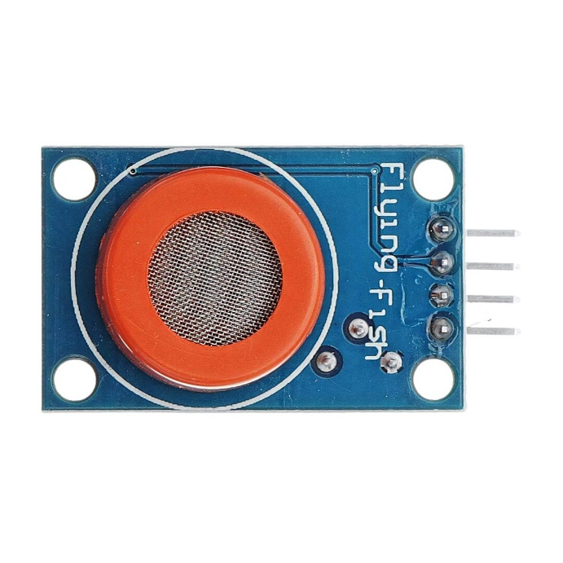
Figure:4.2 MQ-3SENSOR
4.1.3GSM 900a MODULE
` 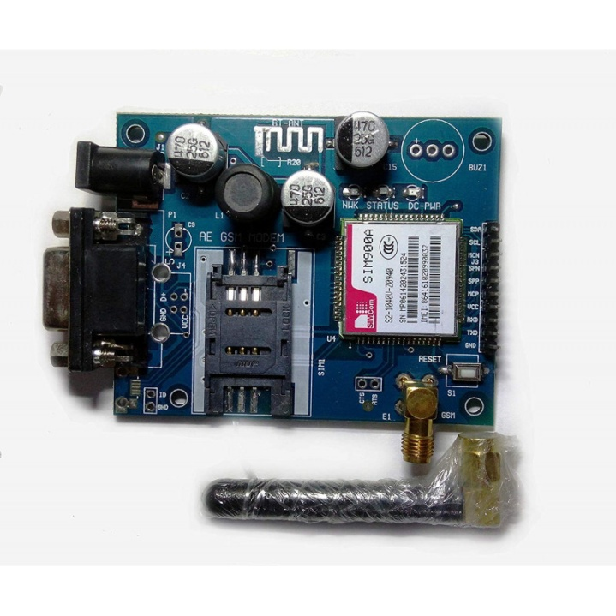

Figure:4.3 GSM 900a module
A SIM900A GSM Module(fig 4.3) is the smallest and cheapest module for GPRS/GSM communication. It is common with Arduino and microcontroller in most of embedded application. The module offers GPRS/GSM technology for communication with the uses of a mobile sim. It uses a 900 and 1800MHz frequency band and allows users to receive/send mobile calls and SMS. The keypad and display interface allows the developers to make the customize application with it. Furthermore, it also has modes, command mode and data mode. In every country the GPRS/GSM and different protocols/frequencies to operate. Command mode helps the developers to change the default setting according to their requirements.

SIM900A Pin Configuration
The Module SIM900A looks like a single chip but it has a bunch of features that can help to build almost many commercial applications. Although, there are a total of 68 pins on SIM900A and using these pins helps to build the applications. But we will need few pins if you we use a module for interfacing with Arduino. We lists details of pinout diagram in next section.

GPIO Pins
The GPIO pins help to perform the simple and advance I/O function. All pins give the maximum output equal to the power supply which is useable to control most of the devices like sensors and other modules. All GPIO pins in SIM900A are:
- GPIO1 – Pin40
- GPIO2 – Pin41
- GPIO3 – Pin42
- GPIO4 – Pin43
- GPIO5 – Pin44
- GPIO6 – Pin47
- GPIO7 – Pin48
- GPIO8 – Pin49
- GPIO9 – Pin50
- GPIO10 – Pin51
- GPIO11 – Pin67
- GPIO12 – Pin68
FEATURES | DETAIL
Power Input | 3.4V to 4.5V
Operating Frequency | EGSM900 and DCS1800
Transmitting Power Range | 2V for EGSM900 and 1W for DCS1800
Data Transfer Link | Download: 85.6kbps, Upload:42.8kbps
SMS | MT, MO, CB, Text and PDU mode.
Antenna Support | Available
Audio Input/output | Available
Serial Port | I2C and UART
Serial Debug Port | Available
4.1.4 RELAY MODULE
A 5V relay module is an essential electronic component used to control high-voltage devices like lights, motors, and appliances with a low-voltage signal from microcontrollers such as Arduino or Raspberry Pi. Operating at 5V DC, it features a built-in relay, driver transistor, indicator LEDs, and protection components like a flyback diode for safe operation. The module can handle loads up to 10A at 250V AC or 30V DC, making it suitable for a wide range of automation and control applications. Its compact, user-friendly design allows easy integration, while electrical isolation—often provided by an optocoupler—ensures that the control circuit remains protected from high-voltage spikes and interference.
WORKING PRINCIPLE
The 5V relay module operates on electromagnetic principles, where a low-voltage control signal activates a switch to manage high-power circuits. When a 5V signal is applied to the input pin (IN), current flows through the relay's control coil, generating a magnetic field. This field attracts an armature (movable contact), connecting the common terminal (COM) to either the normally open (NO) or normally closed (NC) terminal, depending on the relay state. A transistor amplifies the input signal to energize the coil, while a flyback diode prevents voltage spikes from damaging the circuit when the coil de-energizes. Optocouplers in multi-channel modules provide electrical isolation between the control circuit (e.g., Arduino) and the high-voltage load. The module typically handles 10A at 250V AC or 30V DC, making it suitable for controlling lights, motors, or appliances.

PIN CONFIGURATION
- Coil End 1: Connects to 5V power supply (triggers relay when energized with Coil End 2).
- Coil End 2: Connects to ground or control signal (completes the coil circuit).
- COM (Common): Central terminal connected to the load.
- NC (Normally Closed): Connected to COM when the relay is inactive.
- NO (Normally Open): Connects to COM when the relay is activated.
APPLICATIONS
- Home Automation: Controls lights, fans, and appliances via microcontrollers.
- Industrial Automation: Switches motors, pumps, and heavy machinery.
- Robotics: Drives actuators and high-power components.
- Automotive Systems: Manages headlights, wipers, and sensors.
- DIY Projects: Safely interfaces low-voltage circuits with high-power loads.
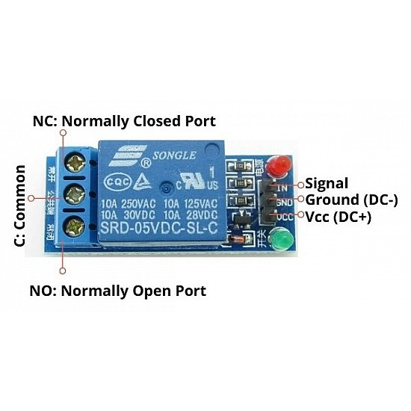
Figure:4.4 5V Relay module

4.1.5 LCD DISPLAY
An LCD display is a widely used output device in electronics projects for visually presenting information such as sensor readings, system status, or user prompts. Commonly, alphanumeric LCDs like the 16x2 or 20x4 modules are interfaced with microcontrollers (e.g., Arduino, PIC, Raspberry Pi) using parallel or I2C communication. These displays operate at low voltage (typically 5V), require minimal current, and are easy to program using libraries like LiquidCrystal in Arduino IDE. LCDs enhance user interaction in projects by providing real-time data display, menu navigation, and feedback, making them essential for automation, monitoring, and control applications.
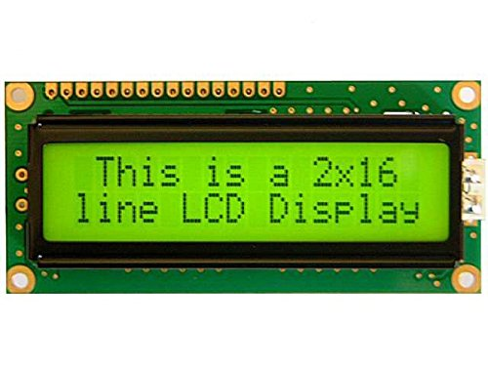
Figure:4.5 LCD Display
4.2 SOFTWARE REQUIRED
4.2.1 ARDUINO IDE:

Arduino IDE IDE stands for “Integrated Development Environment”:it is an official software introduced by Arduino.cc, that is mainly used for editing, compiling and uploading the code in the Arduino Device. Almost all Arduino modules are compatible with this software that is an open source and is readily available to install and start compiling the code on the go. In this article, we will introduce the Software, how we can install it, and make it ready for developing applications using Arduino modules.

- Arduino IDE is an open-source software that is mainly used for writing and compiling the code into the Arduino Module.
- It is an official Arduino software, making code compilation too easy that even a common person with no prior technical knowledge can get their feet wet with the learning process.
- It is easily available for operating systems like MAC, Windows, Linux and runs on the Java Platform that comes with inbuiltfunctions and commands thatplay a vital rolefor debugging, editing and compiling the code in the environment.
- A rangeof Arduino modules available including Arduino Uno, Arduino Mega,Arduino Leonardo, Arduino Micro and many more.
- Each of them contains a microcontroller on the board that is actually programmed and accepts the information in the form of code.
- The main code, also known as a sketch, created on the IDE platform will ultimately generate a Hex File which is then transferred and uploaded in the controller on the board.
- The IDE environment mainly contains two basic parts: Editor and Compiler where former is used for writingthe required code and later is used for compiling and uploading the code into the given Arduino Module.
- This environment supports both C and C++ languages.

ARDUINO IDE
Software can be downloaded from Arduino main website. As I said earlier, the software is available for common operating systems like Linux, Windows, and MACOS,we select to download the correct software version that is easily compatible with our operating system.

Details on IDE: The IDE environment is mainly distributed into three sections
- Menu Bar
- Text Editor
- Output Pane
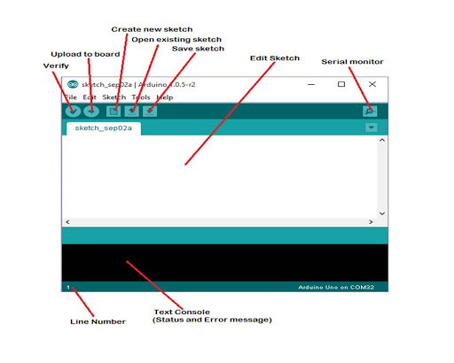
Figure: 4.6 Arduino IDE

The bar appearing on the top is called Menu Bar that comes with five different options as follow:
- File – You can open new window for writing the code or open an existing one. Following table shows the number of further subdivisions the file option is categorized into.
- Menu Bar
- Text Editor
- Output Pane
- Edit – Used for copying and pasting the code with further modification for font Sketch – For compiling and programming
- Tools – Mainly used for testing projects. The Programmer section in this panel is used for burning a bootloader to the new microcontroller.
- Help – In case you are feeling skeptical about software, complete help is available from getting started to troubleshooting. The Six Buttons appearing under the Menu tab are connected with the running program as follow.

    - The Six Buttons appearing under the Menu tab are connected with the runningprogram as follow. A separate pop-up window appears as an independent terminal and plays a vital role for sending and receiving the Serial Data. You can also go to the Tools panel and select Serial Monitor pressing Ctrl+Shift+M all at once will open the Serial Monitor.
- The Serial Monitor will actually help to debug the written Sketches where you can get a hold of how your program is operating. Your Arduino Module should be connected to your computer by USB cable in order to activate the Serial Monitor.
- You need to select the baud rate of the Arduino Board you are using right now.

Program Structure:
- Declarations
- Variables
Whenever you’re using Arduino, you need to declare global variables and instances to be used later on. In a nutshell, a variable allows you to name and store a value to be used in the future. For example, you would store data acquired from a sensor in order to use it later. To declare avariable,you simply define its type, name and initial value. It’s worth mentioning that declaring global variables isn’t an absolute necessity. However, it’s advisable that you declare your variables to make it easy to utilize your values further down the line.
- Instances
In software programming, a class is a collection of functions and variables that are kept together in one place. Each class has a special function known as a constructor, which is used to create an instance of the class. In order to use the functions of the class, we need to declare an instance for it.
- Setup()
Every Arduino sketch must have a setup function. This function defines the initial state of the Arduino upon boot and runs only once. Here we’ll define the following:
- Pin functionality using the pinMode function
- Initial state of pins
- Initialize classes
- Initialize variables
- Code logic Loop() The loop function is also a must for every Arduino sketch and executes once setup() is complete. It is the main function and as its name hints, it runs in a loop over and over again. The loop describes the main logic of your circuit

Serial Plotter Arduino:
serial plotter is another component of the Arduino IDE, which allows you to generate a real-time graph of your serial data. The serial plotter makes it much easier for you to analyze your data through a visual display. You’re able to create graphs, negative value graphs, and conduct waveform analysis

CHAPTER-5
PROPOSED METHODOLOGY
5.1 INTRODUCTION
The proposed methodology focuses on developing a system that detects alcohol consumption in drivers and prevents the vehicle from starting if the alcohol level exceeds a safe limit. The system also enhances vehicle safety by alerting the owner through a GSM-based SMS notification. This method combines hardware components such as an alcohol sensor, microcontroller, engine control system, and GSM module, all working together to ensure real-time detection and response. The flow of operations is designed to be automatic and efficient, providing a reliable way to prevent drunk driving and ensure safer roads.
5.2 MODULE DESCRIPTION
- Alcohol Detection Sensor (MQ-3): The MQ-3 sensor detects alcohol vapors from the driver’s breath. It outputs an analog signal that changes based on the concentration of alcohol, which is then processed by the microcontroller.
- Microcontroller (Arduino UNO): Acts as the brain of the system. It receives data from the MQ-3 sensor, compares it with a predefined threshold, and decides whether to allow the engine to start or cut it off.
- GSM Module (SIM900a): The GSM module sends an SMS alert to the vehicle owner when alcohol is detected or the engine is turned off due to unsafe BAC levels. This ensures the owner is notified instantly, even from a remote location.
- Power Supply: Provides the necessary operating voltage to all components in the system, ensuring smooth functioning of the sensor, microcontroller, and communication modules.
5.3 SUMMARY
This chapter outlines the methodology used to implement the Alcohol Detection and Engine Cut-Off System. It explains the integration of each module and how they work together to detect alcohol, control the engine, and alert the vehicle owner. The proposed approach offers a practical and real-time solution for enhancing road safety and preventing drunk driving.

CHAPTER-6
IMPLEMENTATION AND RESULTS

In this chapter the project’s implementation is shown and all the possible outcomes are seen in the following figures.

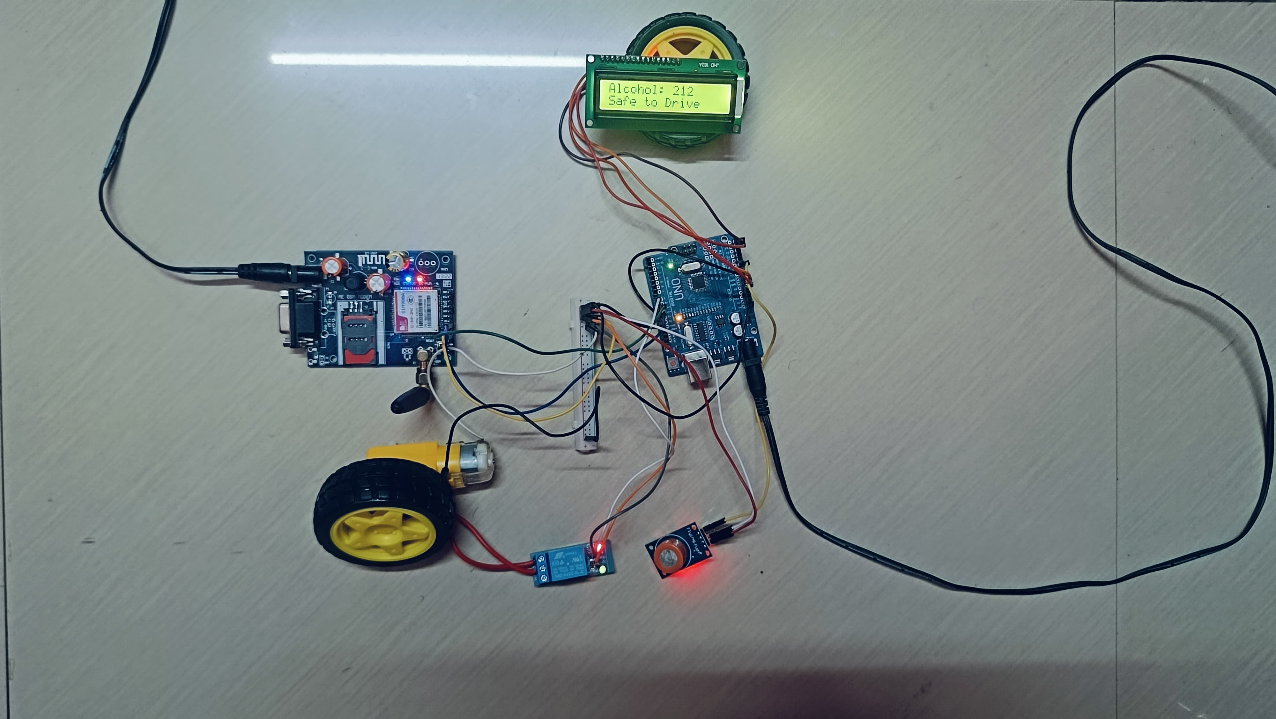
Figure: 6.1 Alcohol detection and Engine Cutoff system

6.1 RESULTS
At initial state when the system is idle it shows “Safe to Drive” and allows the ignition system to start the vehicle.
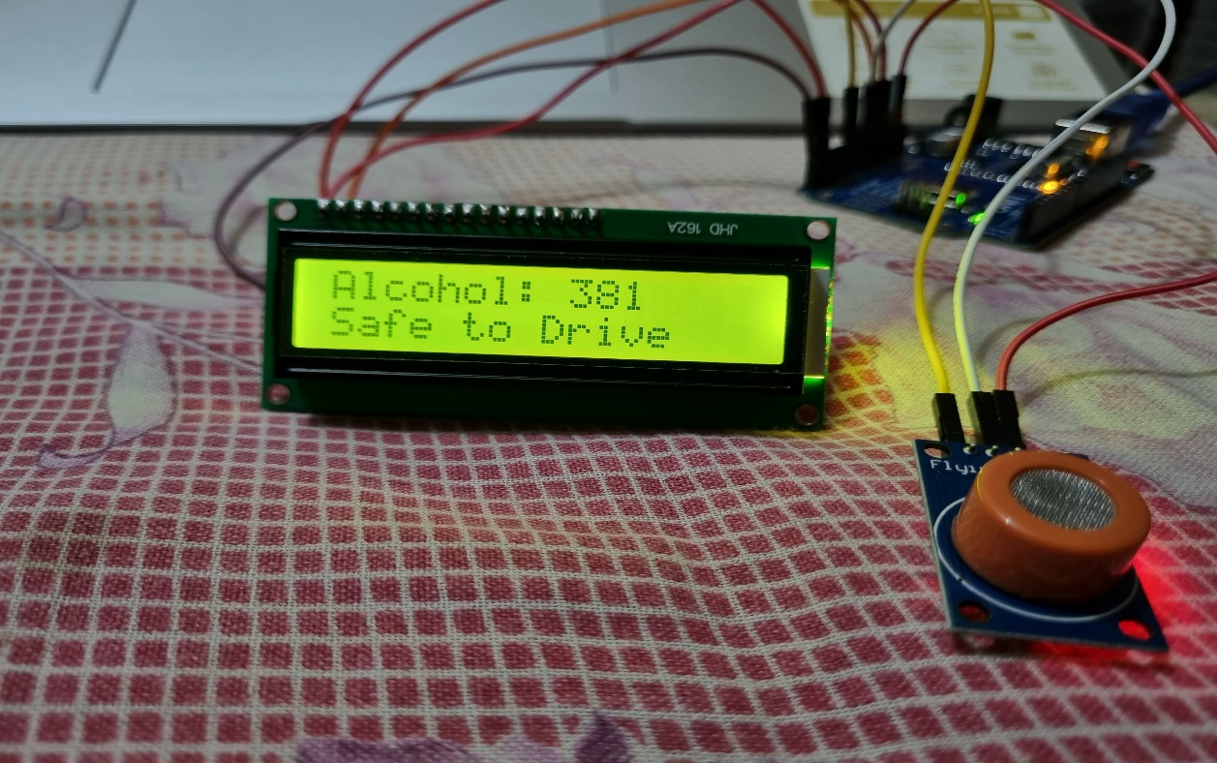
Figure: 6.2 Safe state of the system
Once when the alcohol is detected the indication is shown in the LCD display and the ignition state of the system will be cutoff and immediately an intimation message is sent to the owner of the vehicle.
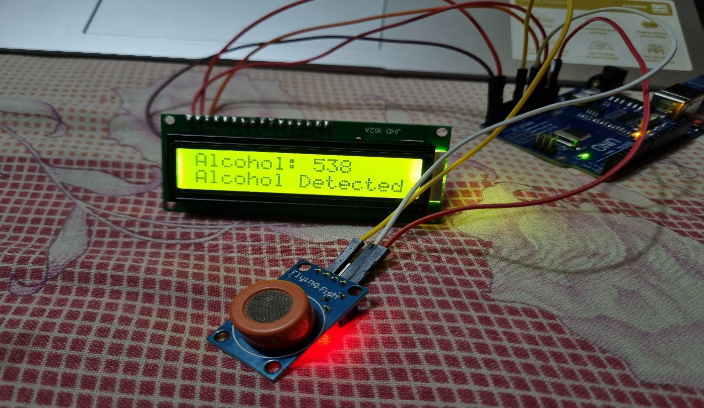
Figure: 6.3 Unsafe state of the system
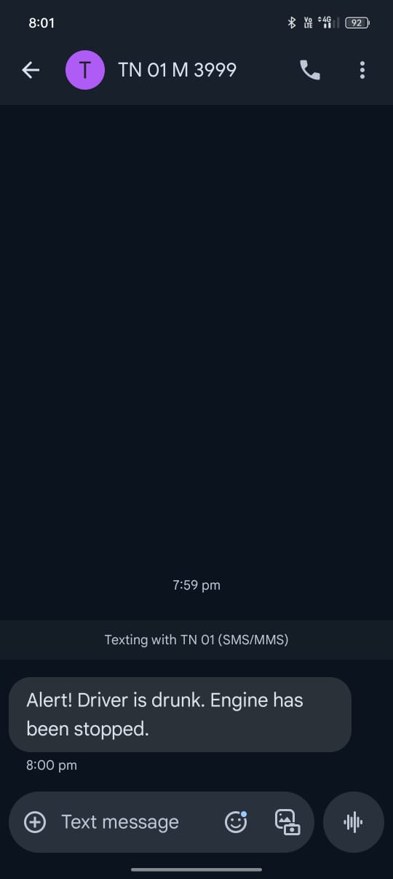
Figure: 6.4 Intimation through message
6.2 SUMMARY
This chapter presents the final implementation of the project along with relevant screenshots showcasing the working setup. It includes images of hardware connections, system output on the LCD, and the response from the GSM module. The results confirm successful alcohol detection and automatic engine cut-off. Overall, the project functions as intended and meets its primary objectives.
CHAPTER 7
CONCLUSION AND FUTURE WORK
7.1 CONCLUSION
The alcohol detection and engine cut-off system was successfully designed and implemented using Arduino and various electronic components. The project effectively detects alcohol levels through the MQ-3 sensor and responds by triggering alerts, sending SMS notifications via the GSM module, and cutting off the engine using a relay. This system demonstrates a practical approach to enhancing road safety by preventing drunk driving. With further development and integration into vehicles, it holds significant potential for real-world applications.
7.2 FUTURE WORK
In future iterations, this project can be enhanced by integrating GPS tracking to monitor the vehicle’s location in real-time. A mobile application can also be developed for remote monitoring and control. Additionally, using a more advanced microcontroller with Wi-Fi or Bluetooth capability, like the ESP32, could improve system performance and connectivity. Further improvements may include voice alerts, real-time data logging, and compact hardware design for easier installation in vehicles.

REFERENCES
[1] Antara Banerjee (Bhowmick). (2018). Alcohol Sensing and Automatic Engine Locking System. International Journal of Creative Research Thoughts (IJCRT).
[2] Arjun Joshi, Akhilesh M., Kushal L. (2024). Alcohol Sensing and Engine Locking System. Journal of Emerging Technologies and Innovative Research (JETIR).
[3] Bansal R. (2024). Implementation of Alcohol Detection System for Driver Safety Measures. International Journal of Creative Research Thoughts (IJCRT).
[4] Dr. Pavan Shukla (2022). Designing an Automatic Engine Locking System Through Alcohol Detection Using Arduino. Anveshana’s International Journal of Research in Engineering and Applied Sciences.
[5] Harsh Pali (2024). Alcohol Detection Engine Locking System with Using IoT. International Journal of Advanced Information Technology and Engineering (IJAITE).
[6] Monisha V. (2018). Automatic Engine Locking System Through Alcohol Detection in Arduino Using IoT. International Research Journal of Engineering and Technology (IRJET).
[7] Pravin Shukla.(2022). Alcohol Detection and Engine Locking System. YMER Digital. 30

[8] Rishabh Tripathi (2022). Automatic Engine Locking System Through Alcohol Detection. International Research Journal of Modernization in Engineering Technology and Science (IRJMETS).
[9] S. S. Patil (2024). Alcohol Detection & Engine Locking with GPS. International Research Journal of Engineering and Technology (IRJET).
[10] Venu Nookala.(2022). Alcohol Detection and Engine Locking System. SSRN.

